**TWO NEW MAJOR FEATURES ADDED TO TABLEAU 2022.4:**

1. **ADDING IMAGE ROLE TO WORKSHEET:**

This new feature allows developer to dynamically add web images to worksheets and use the images as headers to add visual detail to worksheet.

**Steps to add image role:**

From a worksheet:

1. Open a new worksheet.
2. Locate a discrete dimension field that contains image URLs.
3. Right-click (control click on Mac) the dimension field and select **Image Role** > **URL**.  
   The icon changes to an image icon, and your images are ready to use.

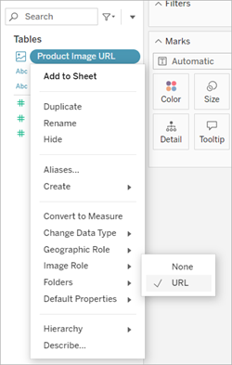

1. Then drag the Image Role field onto the Rows or Columns shelf. You can now see images along with their associated data on your viz.

**Limitations:**

* You can **ONLY** load up to 500 images per field.
* Viz in Tooltip is processed with server-side rendering, which allows you to load up to 30 images per field.
* Now you can use only three image files extensions (i.e. .png, .jpeg, or .jpg)
* No image bigger/larger than 128kb.
* This feature works with **dimension** (STRINGS ONLY).
* An Image Role can be assigned to only URLs.

**Best practice:**

* Always align an Image Role field with a text description to make the content accessible for screen readers and other accessibility software.
* Be sure that the images used in your vizzes are available to be viewed by everyone you share your vizzes with.
* Ensure that each image files are smaller than 128 kb.
* Verify that each URL begins with http or https. If a transport protocol isn’t included, Tableau assumes https.
* Make sure your URLs navigate to image files with .png, .jpeg, or .jpg extensions.
* Verify that your URL doesn't contain any of these characters (< > & \ ^ ') or character sequences (.. \\. \r \n \t).

1. **SWITCHING/REPLACING DATA SOURCES AT WORKSHEET LEVEL:**

This means you use different data sources to build a dashboard in a workbook.

**Steps to replace data source in a worksheet:**

From a worksheet:

1. Go to the sheet tab and select **Data** > **Replace Data Source**.

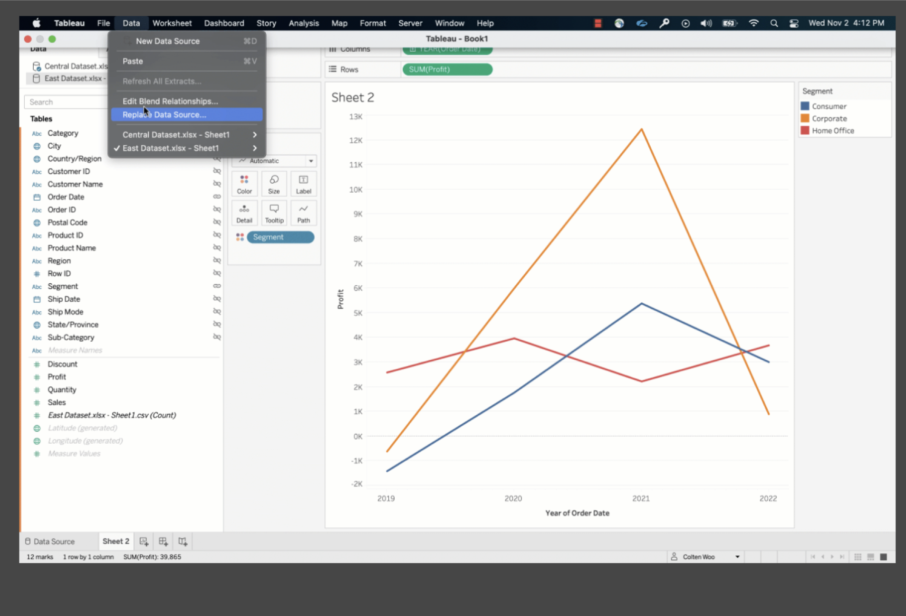

1. In the Replace Data Source dialog box, select the **Current** data source and the **Replacement** data source.
2. Select the box for replace current worksheet only.

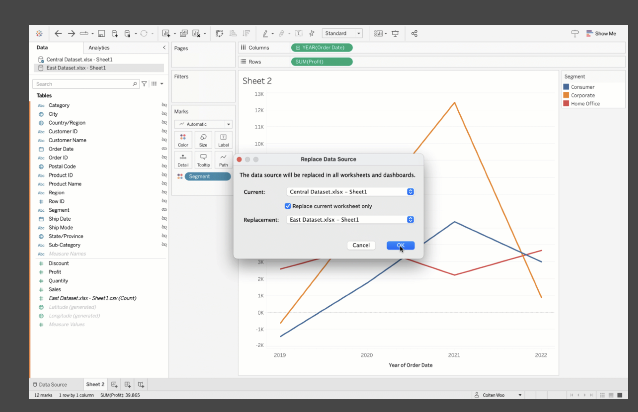

1. When finished, click **OK**.

**Best practice:**

* + You must have at least one field in the view to make the **Replace Data Source** option available.

1. **OTHER FEATURES:**
   1. **A new string function ‘PROPER’ is added to format data further from the worksheet.**
   2. **Additional Connector support:**

* Microsoft OneDrive
* Apache Drill
* Apache Spark SQL
* Cloudera Hadoop Hive
* Datorama
* Dremio Connector
* IBM DB2
* Kyvos
* Qubole Presto